PS_LABSHEET_08

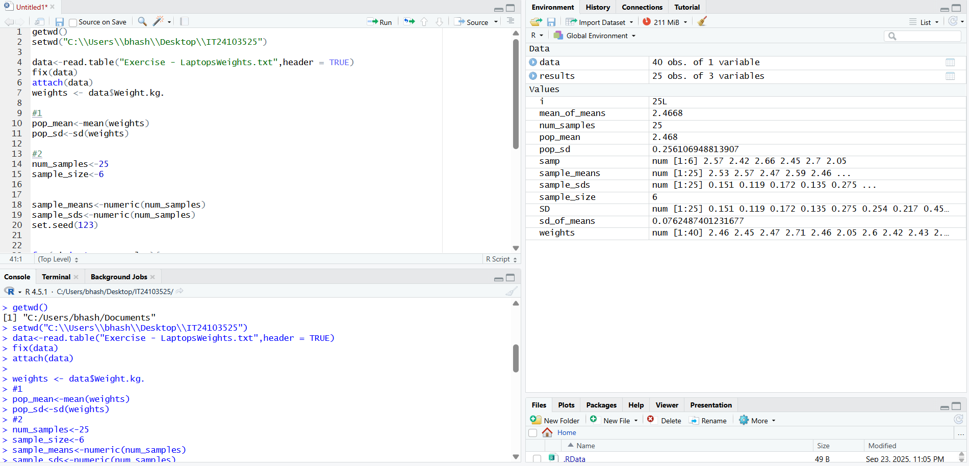

Figure

Figure

Figure

Figure